Singita Sasakwa Private Retreat Safari
Singita Grumeti Reserves, Serengeti
5 Days / 4 Nights
4-8 Persons

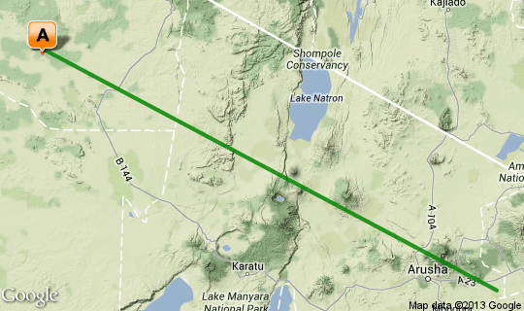

Click here to view your Virtual Itinerary

Overview
Luxury Tanzania private safari at Singita Grumeti Reserves at Sasakwa Lodge for 4 nights in the exclusive 4 bedroom"Private Retreat"

Destination | Accommodation | Nights | Basis | Room Type
Singita Grumeti | Singita Sasakwa Lodge | 4 | FI | 1x 4 Bedroom Retreat

Key
B&B: Bed and breakfast. D, B&B: Dinner, bed and breakfast. FB: Dinner, bed, breakfast and lunch. FB+: Dinner, bed, breakfast, lunch and activities daily. FI: Fully inclusive.

Transport

Flight Information
Day | Flight | Departure Airport | Time | Arrival Airport | Time | Class | Ref
Day 1 | Pilatus PC12 | Kilimanjaro International Airport [JRO] | 0:00 | Sasakwa Airstrip | 0:00 | Private | Included
Day 2 | Pilatus PC12 | Sasakwa Airstrip | TBA | Kilimanjaro International Airport [JRO] | TBA | Private | Included

Transfers
Day | Pick Up | Drop Off | Time | Vehicle
Day 1 | Sasakwa Airstrip | Singita Sasakwa Lodge | TBA | Private 4x4
Day 5 | Singita Sasakwa Lodge | Sasakwa Airstrip | TBA | Private 4x4

Day 1: Serengeti – Singita Grumeti Reserves | Sasakwa Lodge - Retreat

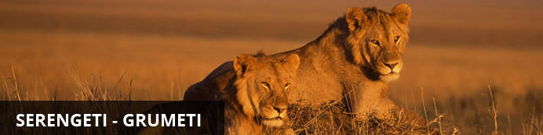
Singita Grumeti is located adjacent to the Western Corridor of the Serengeti, bordering the national park, and encompasses 400,000 acres of unrivalled wilderness. Wide river valleys meandering through the plains, grass lands, woodland and forest. The area forms part of the famous migratory route, which is travelled by hundreds of thousands of animals every year. Grumeti features unparalleled exclusivity combined with the ability to enjoy a wide selection of activities not allowed inside the Serengeti as it not governed by national park regulations.
The famous Great Migration, an annual trek of 2 million animals through the Serengeti-Mara ecosystem, bisects our reserve annually. Called The Greatest Wildlife Show on Earth it has, since time immemorial, been the dramatic backbone of this enormous wilderness.

Day Description
Arrival to in to Kilimanjaro Airport (JRO) with own private jet or on commercial airline ( details TBA)
Clear customs and immigration in to Tanzania – VISA on arrival US$50 per person in cash or US$ 100 for USA Nationals
Onward private air charter arranged with Pilatus PC12 aircraft ( turbo Prop Pressurized single engine) from Kilimanjaro to Sasakwa Airstrip ( Singita Grumeti Reserves) - flying duration 47mins
On arrival at Sasakwa Airstrip met by your private landrover 4x4 and assigned ranger for the short transfer +_ 10mins from airstrip to Sasakwa Lodge, Private Retreat ( 4 Bedrooms).
Arrival for lunch and to settle in to your accommodation for your 3 night safari at Singita Grumeti Reserves.
Situated on the western corridor of the world famous Serengeti National Park, Singita Serengeti House will offer guests exclusive use accommodation and access to 350,000 acres of private land, providing an unparalleled safari experience.
Singita boasts one of the best equestrian centres in Africa and offers spectacular horse riding safaris across the vast, private, game filled plains of Singita Grumeti. Situated on the western corridor of the Serengeti, and spanning an area almost the size of the Masai Mara, Singita Grumeti offers an exclusive and unparalleled horseback safari teeming with magnificent wildlife encounters.

4 overnights: Singita Sasakwa Lodge | Private Retreat ( 4 bedrooms)
Singita Sasakwa Lodge is one of three Singita lodges in this enormous private concession (350 000 acres), which means that you’ll have this wild stretch of Africa all to yourself. Sasakwa Lodge is built in the style of an Edwardian manor house. Stone walls, deep verandas, high ceilings, stately furniture, silverware and ornamental pieces complete the picture. Each cottage has a private infinity-edge pool overlooking ‘where the land stretches to forever’. The bedrooms with inviting four-posters are beautifully appointed, displaying typical African influences with touches of wood, leather and grass, alongside crisp linens, imported chandeliers and hand-crafted furniture.
Nine luxurious cottages and a private retreat.
At any one time Sasakwa can accommodate a total of 34 guests.
Cottage configurations: 6 x 1 bedroom, 2 x 2 bedrooms, 1 x 3 bedrooms, 1 x 4 bedrooms (private retreat).
The Private Retreat(4 bedrooms) contains a basement nanny flat, which has two twin bedrooms, both en-suite
Each air-conditioned cottage features a bedroom, en-suite bathroom with bath and shower, lounge with fireplace, dressing area, a guest toilet, veranda with a Swarovski spotting scope and a heated infinity plunge pool.
Cottages have a personal bar and fridge, electronic safe, direct dial telephone (US lines) and wireless internet access.
Includes include all-suite accommodation, three meals per day, all drinks, including premium wines, spirits and liqueurs (excluding vintage champagne, champagne, and vintage wines on the connoisseurs wine list) and open Land Rover safaris accompanied by an experienced guide.
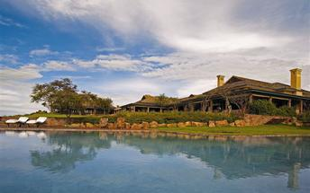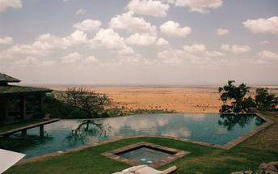

Activities
Private morning and afternoon 4x4 safari drives each day accompanied by experienced guides, guided , walking safaris, mountain biking, tennis and archery. Horse riding – All equestrian day trips from Sasakwa should be booked in advance, especially in season, to avoid disappointment.

Included
Bed, All Meals, Most Drinks(local), Fees, Activities
- Surface transfers to the camps from Sasakwa Airstrip.
- Luxury accommodation, laundry, valet services, wireless internet access, dial direct telephone in all rooms,
satellite television at Singita Sasakwa, DVD player, play station and an array of board games in the library /
lounge
- All meals and game drives drinks and canapés, all beverages, fine wines, sparkling wines, selected champagnes (excluding French) and cognacs.
- Private morning and afternoon 4x4 safari drives each day accompanied by experienced guides, guided
walking safaris, mountain biking, tennis and archery.
- Horse riding – All equestrian day trips from Sasakwa should be booked in advance, especially in season, to
avoid disappointment.
- All local taxes, emergency evacuation insurance and VAT.

Recommended
Private hot air ballooning over Serengeti Plains

Day 2: Serengeti – Singita Grumeti Reserves | Sasakwa Lodge - Retreat

Day Description
Morning safari before breakfast in private 4x4 vehicle.
Return to the lodge for breakfast, or maybe breakfast will be arrange in a remote location on the plains.
Time to relax at the lodge with lunch or take in extra activities on offer at Sasakwa.
Afternoon tea on the lawns, before heading back out on safari in to the reserve.
Return to the lodge for spectacular dinner with fine wines, cognac's and cigars.
Overnight Sasakwa Lodge Private Retreat

Activities
Private morning and afternoon 4x4 safari drives each day accompanied by experienced guides, guided , walking safaris, mountain biking, tennis and archery. Horse riding – All equestrian day trips from Sasakwa should be booked in advance, especially in season, to avoid disappointment.

Included
Bed, All Meals, Most Drinks(local), Fees, Activities
- Surface transfers to the camps from Sasakwa Airstrip.
- Luxury accommodation, laundry, valet services, wireless internet access, dial direct telephone in all rooms,
satellite television at Singita Sasakwa, DVD player, play station and an array of board games in the library /
lounge
- All meals and game drives drinks and canapés, all beverages, fine wines, sparkling wines, selected champagnes (excluding French) and cognacs.
- Private morning and afternoon 4x4 safari drives each day accompanied by experienced guides, guided
walking safaris, mountain biking, tennis and archery.
- Horse riding – All equestrian day trips from Sasakwa should be booked in advance, especially in season, to
avoid disappointment.
- All local taxes, emergency evacuation insurance and VAT.

Day 3: Serengeti – Singita Grumeti Reserves | Sasakwa Lodge - Retreat

Day Description
Full day Migration Safari in Southern Serengeti or Northern Serengeti depending on location of herds .
Departure with private aircraft from Sasakwa to Southern Serengeti plains for a full day safari.
Based on Pilatus PC12 and game drive in Ndutu / Serengeti National Park (with park fees included to have the flexibility of entering both areas)to cover the best areas where the migration herds will be and they are in calving season
Flight from Singita Sasakwa airstrip - Ndutu, where we have a 4x4 vehicle waiting from the airstrip for full day game drives amongst the herds and fly back end of the day, or depending on season differing location.
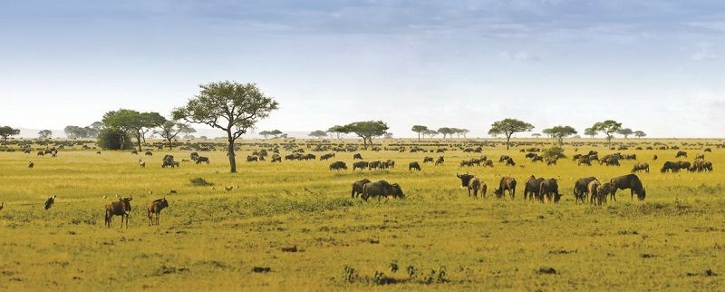
Note: Important to note that plane will need to leave around 16:00 latest as it needs to drop off at Sasakwa airstrip and continue to Arusha airport , landing before dark.
Overnight Sasakwa Private Retreat ( 4 bedrooms)

Activities
Migration safari

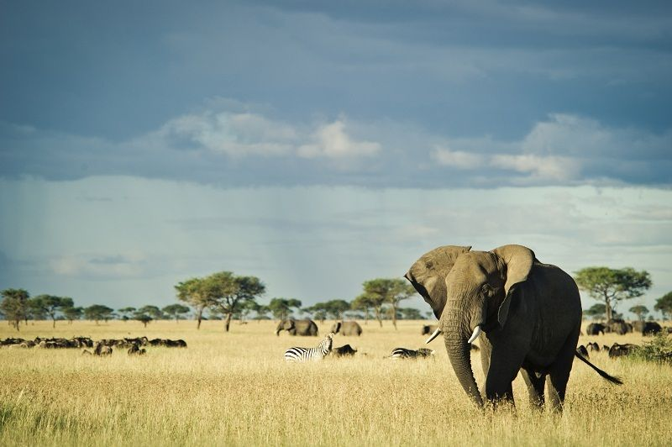

Day 4: Serengeti – Singita Grumeti Reserves | Sasakwa Lodge - Retreat

Day Description
Early Morning Private Balloon safari over the plains of Singita Grumeti Reserves for the family to enjoy as their first experience to survey their surroundings from above.
Return back to the lodge and lunch at leisure, before afternoon safari and other activities on off at Singita Grumeti Reserves, with private landrover and guide.
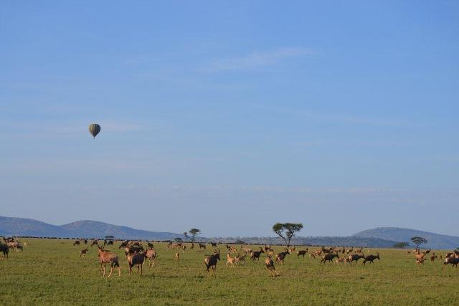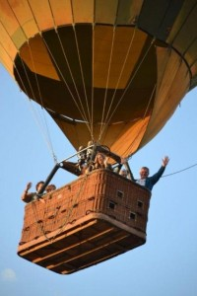

Overnight Sasakwa Private Retreat ( 4 bedrooms)

Included
Bed, All Meals, Most Drinks(local), Fees, Activities
- Surface transfers to the camps from Sasakwa Airstrip.
- Luxury accommodation, laundry, valet services, wireless internet access, dial direct telephone in all rooms,
satellite television at Singita Sasakwa, DVD player, play station and an array of board games in the library /
lounge
- All meals and game drives drinks and canapés, all beverages, fine wines, sparkling wines, selected champagnes (excluding French) and cognacs.
- Private morning and afternoon 4x4 safari drives each day accompanied by experienced guides, guided
walking safaris, mountain biking, tennis and archery.
- Horse riding – All equestrian day trips from Sasakwa should be booked in advance, especially in season, to
avoid disappointment.
- All local taxes, emergency evacuation insurance and VAT.

Day 5: Departure

Day Description
Breakfast at Sasakwa Lodge
Transfer to the airstrip where you are met by your private Pilatus PC12 aircraft for the flight back to Kilimanjaro ( flight duration 47mins)
Connect with your onward flight arrangements or own private jet for onward flight to onward destination.

END OF SERVICES

